**AUTHOR GUIDELINE**

**International Students’ Conference on Accounting and Business (iSCoAB)**

**PAPER FORMAT**

1. Paper should be written in English and include the author's name, affiliation, and the authors' email address.
2. First author of the paper should be a student.
3. Paper can be qualitative or quantitative and should fall into the iSCoAB topic areas: Financial Accounting, Management Accounting, Auditing and Information Systems, Public Sector Accounting, Sharia Accounting, Banking and Business, Taxation, and Behavioral Accounting.
4. Paper must be an original work and has never been published in any journal.
5. Paper should be written in a total of 10 to 20 pages.
6. Direct quotation should be typed using single line spacing and in indented style.
7. Paper must be written in Microsoft Word on A4 paper size and single spacing. With file format, 3 cm margins for each side (top, bottom, right, and left), with Calibri Light font type, 11pt font size and justified to the right and left.
8. All pages must be numbered, including reference and appendix.
9. Authors are encouraged to use the Mendeley application for citation and referencing.
10. Paper must follow iSCoAB’s template of manuscript. The iSCoAB’s template is presented here in the last page.

**PAPER STRUCTURE**

Paper should at least consist of the followings:

1. **Title.** Title should be attractive, describe the contents of the paper and consist of no more than 12 words.
2. **Authors’ Name, Institution and Email Address.** Author's name is stated without an academic degree, followed by the affiliation and email address of each author. Correspondence author is marked with (*).
3. **Abstract and Keywords.** Abstract should be written from 150 to 250 words, needs to be written in English, and contain at least a summary of the research objective, method, result, conclusion and implication. Abstract is not allowed to contain references/quotations and should be followed by 3 to 5 keywords.
4. **Introduction.** This section should at least provide an explanation of research background, novelty, objective and contribution.
5. **Literature Review and Hypothesis Development (If any).** This section contains previous literature related to the research and explains the hypothesis development (if any). Hypotheses are built based on relevant theory, previous studies, and logical arguments.
6. **Research Method.** Research methods should at least describe research design, population and sample, data collection technique, variable measurement, and data analysis techniques.
7. **Results and Discussion.** This section explains the result of data analysis, finding, and its interpretation.
8. **Conclusion.** Conclusion presents research conclusion, implication, limitation, and future research opportunity.
9. **Reference.** Reference should be written in APA style, in alphabetical order, without numbering. Author is encouraged to use reference manager applications, such as Mendeley or EndNote.

##### **PAPER TEMPLATE**

PAPER TITLE (no more than 12 words, Calibri Light 14, UPPERCASE)

First Author Name1*, Second Author Name2, Third Author Name3

1*Affiliation, email address

2Affiliation, email address

3Affiliation, email address



**Abstract**

(Calibri Light 11, Bold, single spaced, 4 pt spacing before, 2 pt spacing after)

Abstract is written briefly and clearly in one paragraph (150 to 250 words) and is written in English. It should inform the reader briefly about the research purpose, method, finding, conclusion, and implication. References are not allowed to be cited in abstract. Abstract contains 3-5 keywords or phrases. (Calibri Light 10, single spaced, 0 pt spacing before, 0 pt spacing after)

Keywords: content, format, articles.



**INTRODUCTION (Calibri Light 11, Bold, 1.5 spaced, 2 pt spacing before, 4 pt spacing after)**

This section contains research background, objective, novelty, and contribution (theoretical and/or practical). Research novelty should be written explicitly (Calibri Light 11, single spacing, 0 pt spacing before, 0 pt spacing after).

**LITERATURE REVIEW AND HYPOTHESIS DEVELOPMENT (Calibri Light 11, Bold, 1.5 spaced, 4 pt spacing before, 2 pt spacing after)**

This section contains previous literature related to the research and explains the hypothesis development (if any). Hypotheses are built based on relevant theory, previous studies, and logical arguments. State your hypothesis (if any) explicitly in the following format:

***H1: hypotheses is written in bold and italic***

Hypotheses are not mandatory, especially for qualitative research (Calibri Light 11, single spaced, 0 pt spacing before, 0 pt spacing after).

**RESEARCH METHOD (Calibri Light 11, Bold, 1.5 spaced, 4 pt spacing before, 2 pt spacing after)**

Research method should at least describe research design, population and sample, data collection technique, variable measurement, and data analysis techniques (Calibri Light 11, single spaced, 0 pt spacing before, 0 pt spacing after).

**RESULTS AND DISCUSSION (Calibri Light 11, Bold, 1.5 spaced, 4 pt spacing before, 2 pt spacing after)**

This section is the main body of a research article and is usually the longest section of a paper. The data analysis process and the hypothesis testing process do not need to be presented. Only results of analysis and results of hypothesis testing should be reported. Tables and graphs can be used to clarify the presentation of research results. Tables and graphs should be commented on or discussed. For qualitative research, the results section contains detailed sections in the form of sub-topics that relate directly to the research focus and its categories (Calibri Light 11, single spaced, 0 pt spacing before, 0 pt spacing after).

**CONCLUSION (Calibri Light 11, Bold, 1.5 spaced, 4 pt spacing before, 2 pt spacing after)**

This section contains research conclusion, implication, limitations, and opportunities for further research. Research limitations should be followed by research suggestions which may include aspects that can be considered to improve future research (Calibri Light 11, single spaced, 0 pt spacing before, 0 pt spacing after).

**REFERENCE (Calibri Light 11, Bold, 1.5 spaced, 4 pt spacing before, 2 pt spacing after)**

**Journal**

Author, A., & Author, B. (year). Article Title. *Journal Name*, volume(issue), page. <https://doi.org/xxxx>

**Example:**

Felstead, A., Jewson, N., Phizacka, A., & Walters, S. (2002). Opportunities to work at home in the context of work-life balance. *Human Resource Management Journal*, 12(1), 54-76. <https://doi.org/xxxx>

**Book**

Author, A., & Author, B. (Copyright Year). *Book Title (edition).* Publishers. DOIs or URLs.

**Example:**

Hair, J.F., Black, W.C., Babin, B.J., Anderson, R.E., & Tatham, R.L. (2006). *Multivariate data analysis*. Upper Saddle River, NJ: Pearson Education Inc.

**Part of a book**

Author, A., & Author, B. (year). Book chapter titles. In AA author & BB author (Eds.), Book Title (2nd ed., pp. #–#). Publishers. DOIs or URLs.

**Example:**

Berry, W. (2005). War does not maintain peace or promote freedom. In LI Gerdes (Ed.), War: Opposing viewpoints (pp. 71-79). Detroit, MI: Greenhaven Press.

* 1. **Equation**

Equation should be written in Calibri Light font 11. If more than one equation is presented, each equation must be numbered. The number must be sequential and placed on the far right as (1), (2), and so on. Use italics for variables, bold for vectors.

## $n=\frac{N}{1+Ne^{2}}$................................................................................. (1)

## **Figure and Table**

Title must be placed above table or below figure and must be numbered. Examples of presenting table and figures are as follows:

Table 1. Table Format

| Table Head | Table Column Head | |
| --- | --- | --- |
| Column Sub-head | Column Sub-head |
| Content | Table Contents | Table Contents |
| Content | Table Contents | Table Contents |
| Content | Table Contents | Table Contents |
| Source: Table source | | |

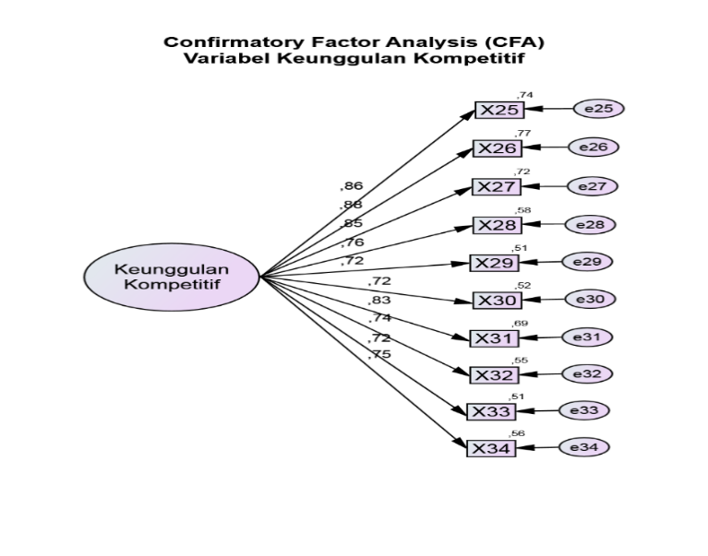

Figure 1. CFA Competitive Advantage